12th EUROPEAN CONGRES OF DENTO-MAXILLO FACIAL RADIOLOGY 2-5 JUNE 2010
Head and Neck Inflammation. Differential Diagnosis – Homeopathic approach
Michalakis Michael, DDS, MSc
Michalaki Dernikou Fotini DDS, MD, Msc

INTRODUCTION: Inflammation often initiates within the maxillofacial region, Peritonsillar abscess is a common deep infection of the head and neck that occurs in the population. This infection begins as a superficial infection and progresses into tonsillar cellulitis. Early diagnosis of the abscess allows appropriate treatment to begin before the abscess spreads into the surrounding anatomic structures. Dental infections were the most common cause of deep neck abscesses (49.1%) . The procedure for patients to received systemic antibiotics and in some cases surgical drainage in the operating room is often required. Median and lower quartile of time in hospital was 2 and 3 days, whereas upper quartile was 4 days (range, 1 to 27 days).
The beneficial approach of homeopathy will be introduced through individual cases that have been recorded.
In each case the Aim was to set Diagnoses using the data acquired following intra and extra oral dental examination and complete homeopathic interview. The clinical findings and the subjective patients’ symptoms were analyzed using RADAR 9 computer software which proposes as a list of remedies that can cure the totality of symptoms.
Repertorisation: allows as a precise differential diagnosis of possible homeopathic medicines through login of the symptoms, since only one remedy can be prescribed for a reasonable amount of time according to the rules of classical homeopathy.
The Method requires:
I) Dental history
II) Homeopathic history (birth till present).
III) Symptoms analysis in their totality with additional literature.
Use of computer software (Radar)
IV) Clinical evaluation of the case& prescription followed with recall after one month.(minimum)

Case 1 At 15-9-09 visited the office with symptoms of facial Palsy left.
Man age 52y. W:103kg/H:174cm, married
Medical history: Hospitalized at 7 till 9 Sep 2009 at Athens medical hospital. Diagnosis set as facial palsy left (peripheral type).Falling mouth corner left, Taste distortion-Inability to lift eyebrows left. Para clinical examinations: Blood analysis/ MRI / Rx/ electroencephalograph EEG/ Triplex carotid/ CT scan-brain.
No pathological findings / Prescribed with: O tabl 2x2/day for 3days Medrol, Zantac 5 caps, Tears natural 2drops /2 hours.

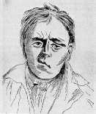

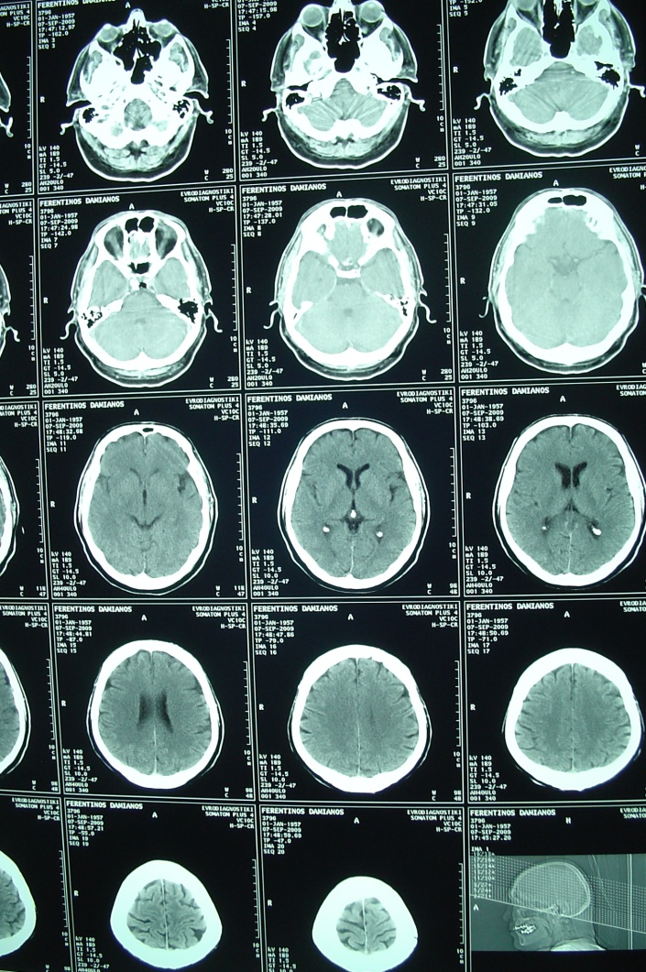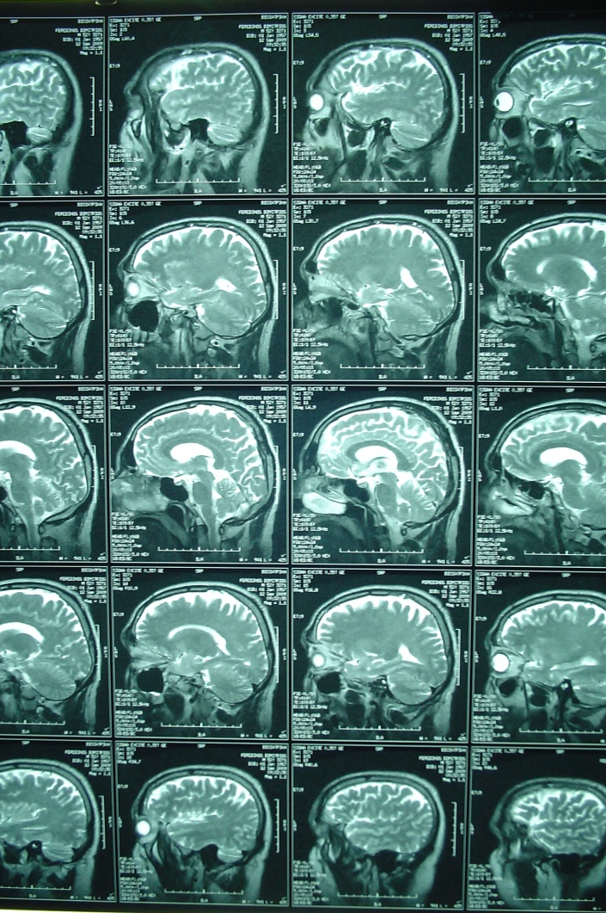
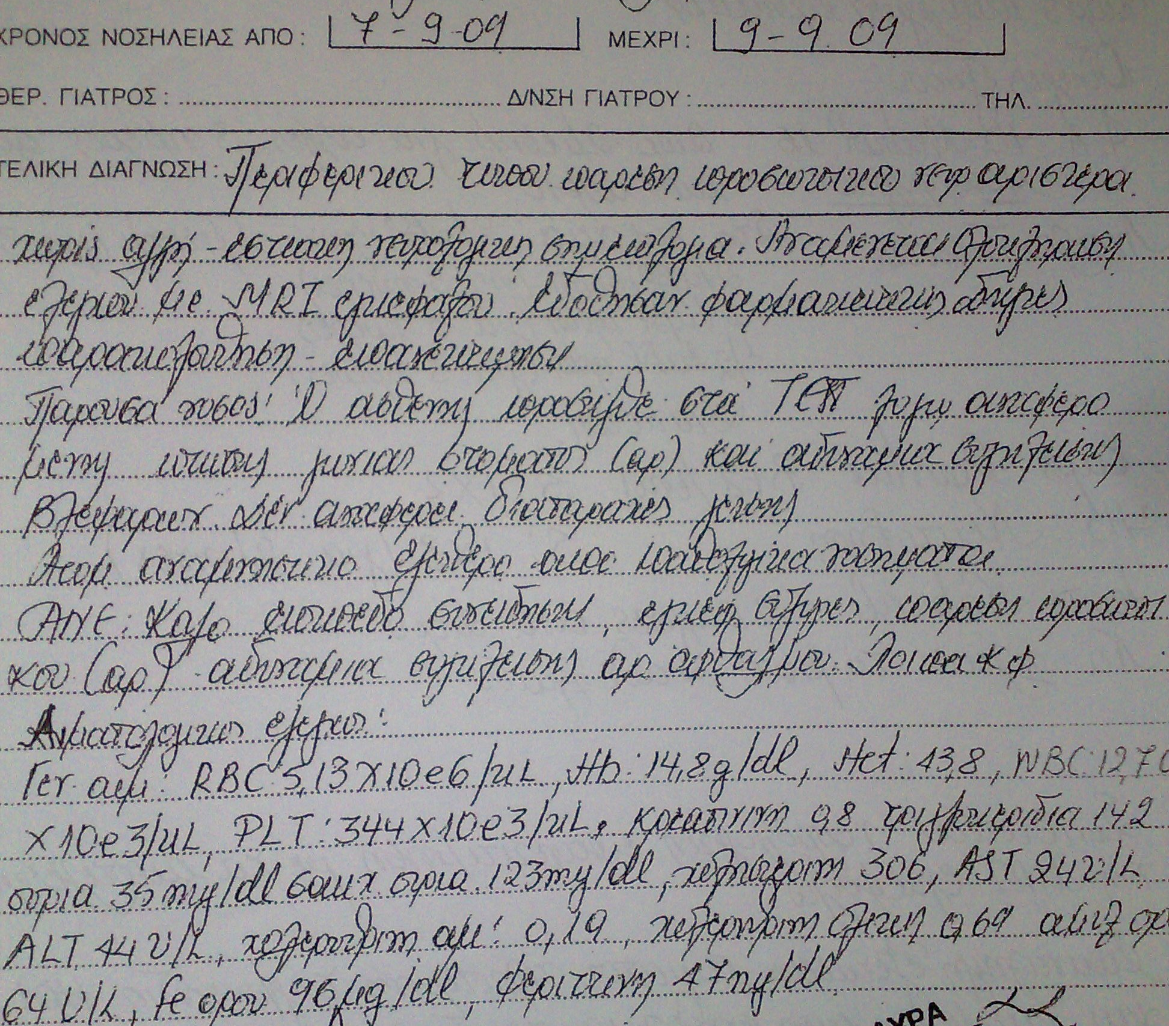
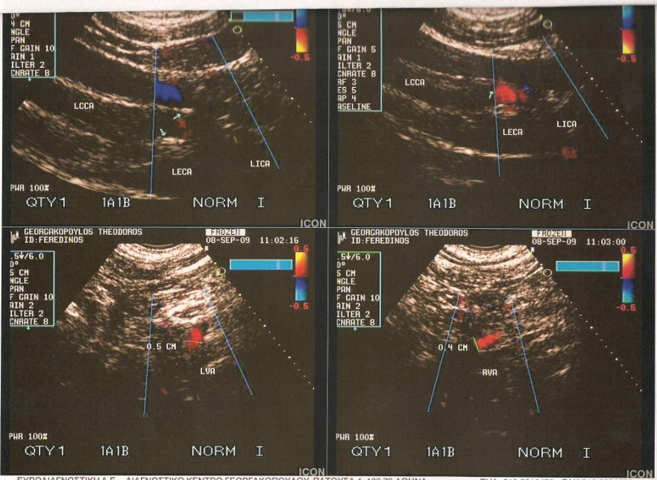

Following the logging of the symptoms using Computer software(Radar)-repertorization.
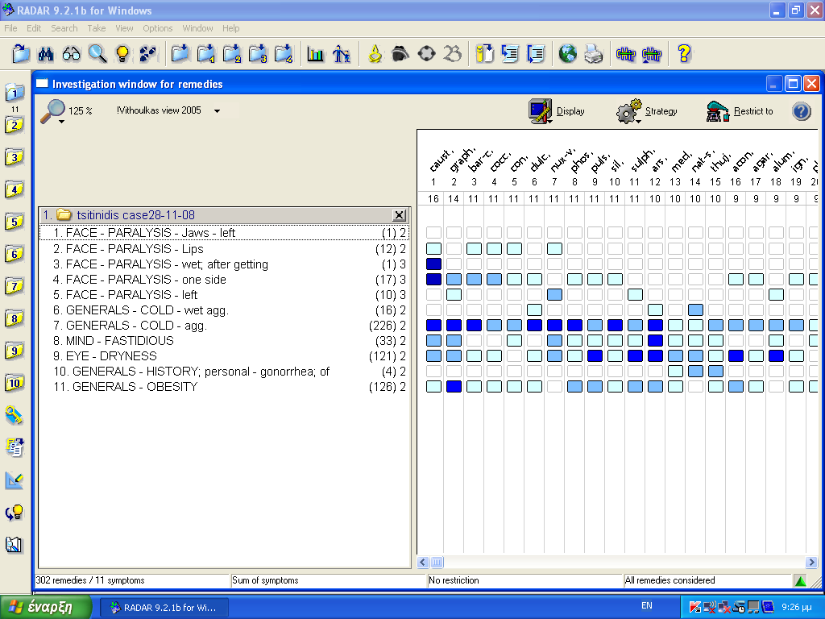
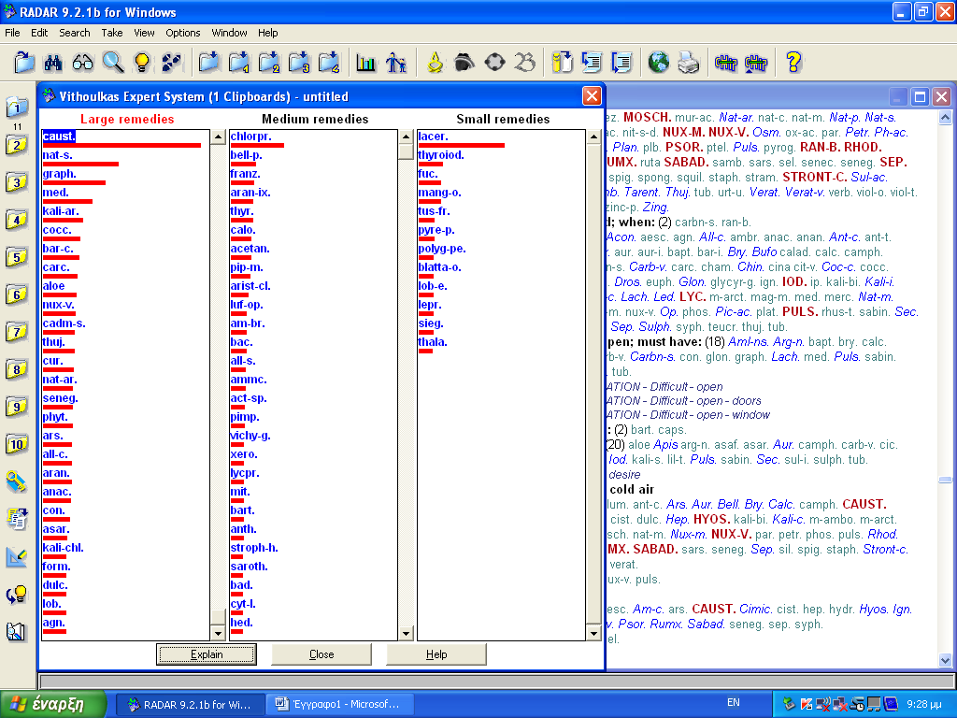
Treated:15-9-09 O. 1/day caps Causticum 30CH x 10,/ Caus.12CH x 10
27-11-09 follow up
27-1-10 O. 1/day caps mercury 30CH x2, 200CH,12CH x10.
Outcome observations: case 1 Facial muscles mobility (left side) recovered hours after receiving 1st dose of Causticum.
Case2 Peritonsilar abscess recurrent. (PTA) Man age 50y, W:88kg /H:185cm past history: 8/2006 PTA left
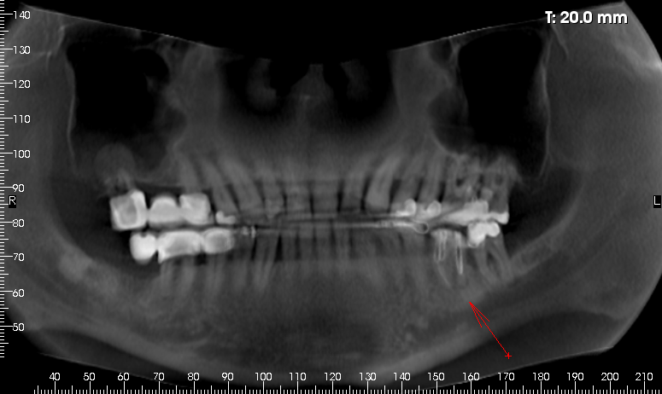
23-7-09 hospitalized diagnosed with PTA treated with augmentin and surgically drainage twice.
29-7-09 visited the office with PTA recurrent left.

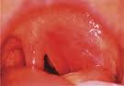

27-9-09 xerostomia
27-1-10 shore throat left tonsil red
1-6-10 follow up
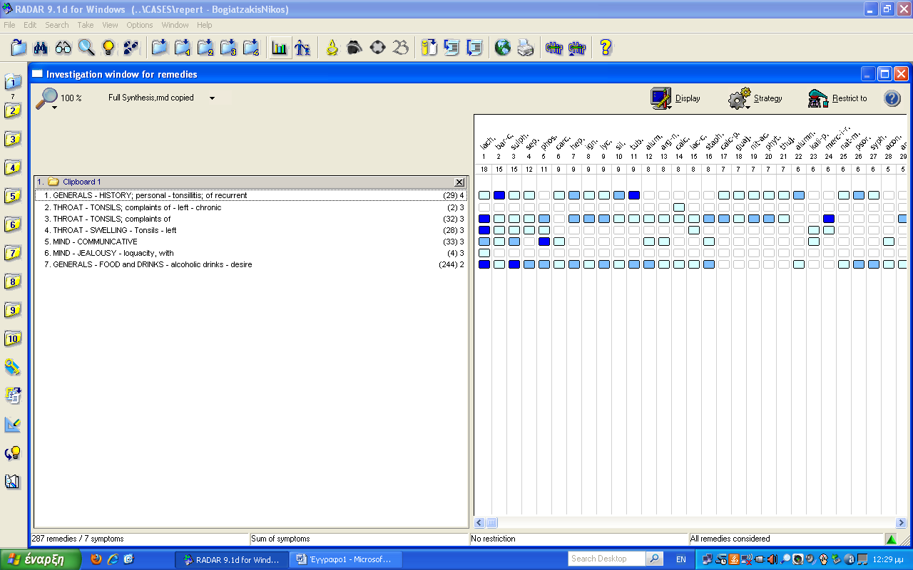

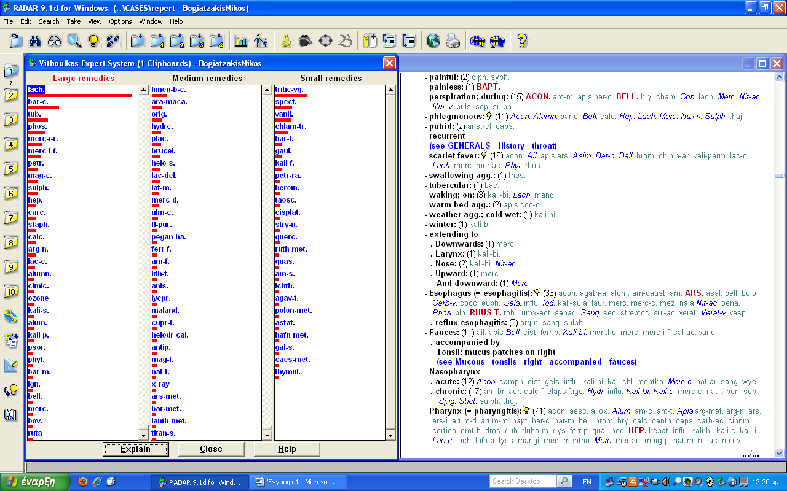

Treated: 29-7-09 O. 1/day caps Lachesis 200 Ch/1M x 1
27-9-09 O 1/day caps medorhinum 200Ch x 1
27-1-10 O. 1/day caps Mercury iodadus ruber 30Ch x 4

Outcome: inflammation symptoms(PTA) recovered within 48 hours
Present condition 1-6-2010 : ( asymptomatic formation Distal to 37)
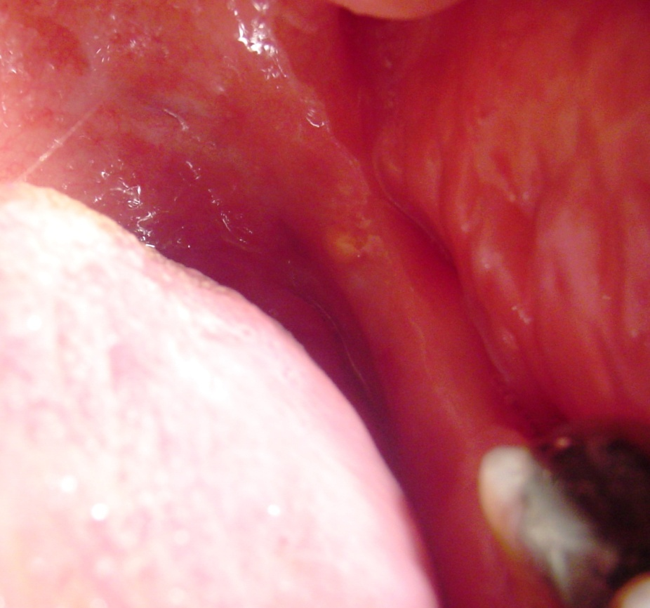
Clinical notes: restorations at 47,46,27&17 should be revaluated.

Case 3 19-3-09 woman married 45kg/ H:168cm, 43Y
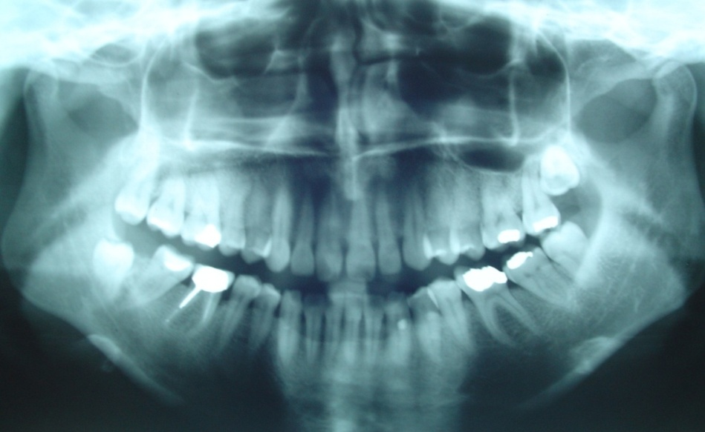
Medical history : colic kidney since youth , cysts ovaries ,surgically removed twice left, hemoglobin low, gastro-esophagitis periodic complaints.
Main complaint shore throat initiating with irritation at 37-38 lingual gums recurrent/3-4 months.
Clinical notes: hygiene of the oral cavity is excellent, no restoration need to be done at present, extraction of 38&28 are planned. Homeopathy was suggested to relief the patient:
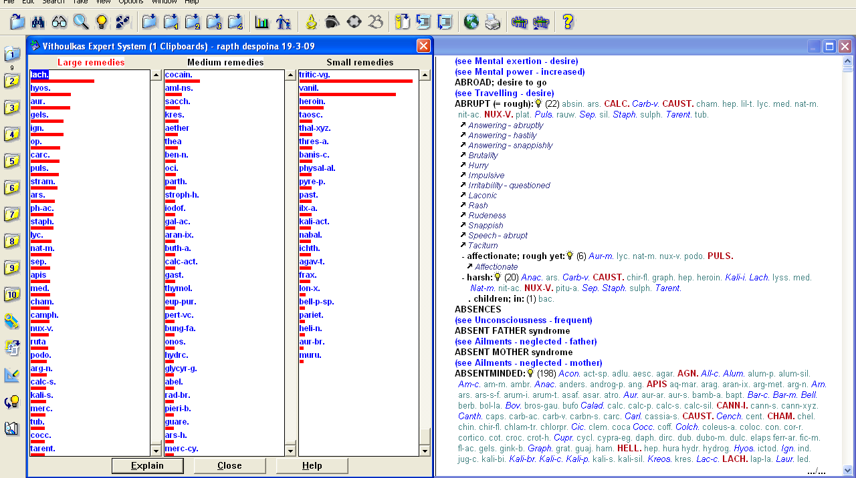
Treated:19-3-09 Lachesis 200Ch
Follow up 6-5-09 Lachesis -//- for irritation left neck lymph node (anterior cervial)
Follow up.26-2-10 no complaint.

Conclusion: Homeopathy uses the symptoms in totality as obtained through the medical history to show up the right medicine, it works fine with rules and training standards set by ECH. Radiologists who are among the first to receive medical history, have the opportunity to inhibit the progression of inflammation into more profound structures and relief the patient, using more than 3 thousands recorded remedies in homeopathic literature since Hahnemann has discovered homeopathy back in 1810.
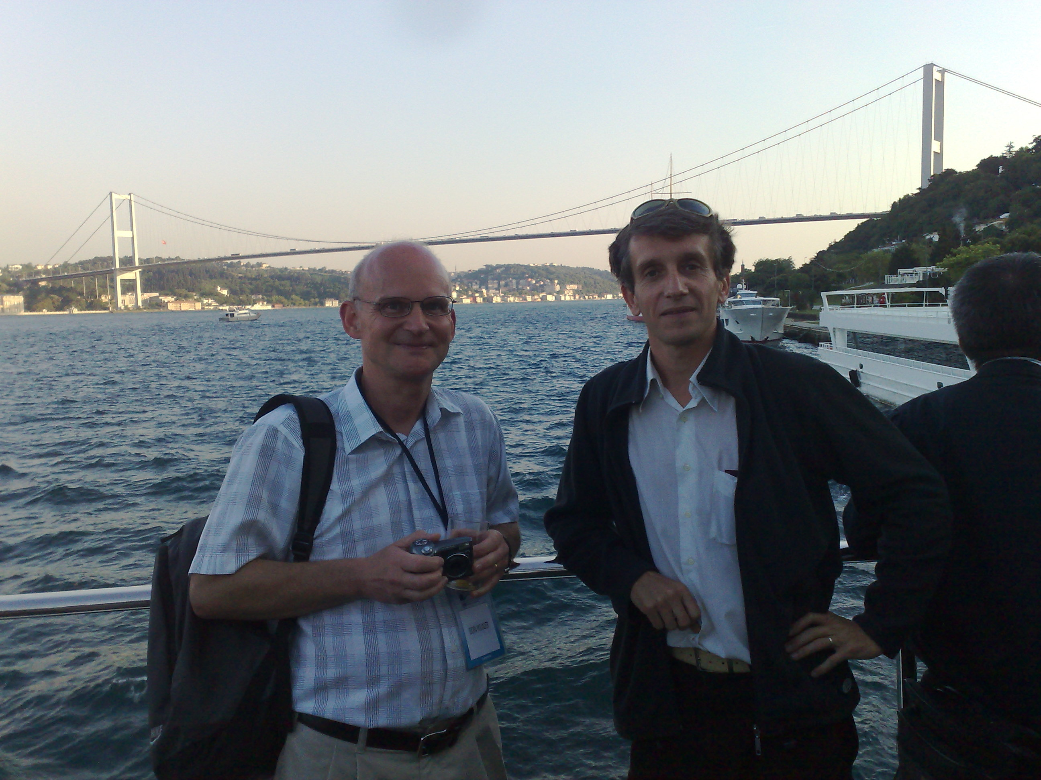
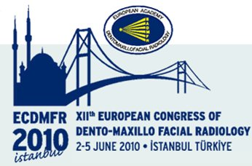
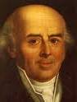

Q (Chairman): Are the clinical effects of homeopathy placebo effects?

References: Case report
1) Oral pathology Regezi&Sciubba
2) Παπαγεωργίου Ε. Νευρολογία 2η Έκδοση Αθήνα 1997
3) Portraits of Homeopathic Medicines Catherine R. Coulter
4) Oral Diseases & Homeopathy Dr Shiv Dua
5) BERGAMINI L. Manuale di Neurologia. Clinica. Liberia Cortina eds. Torino 1983
6) Textbook of dental homeopathy Dr Collin B. Lessell
7) Grants atlas of anatomy Anne M.R. Agur 1991.
8) Radar - International Academy of CLASSICAL HOMEOPATHY

